***Chapter – 1 Mobile Money Basics***

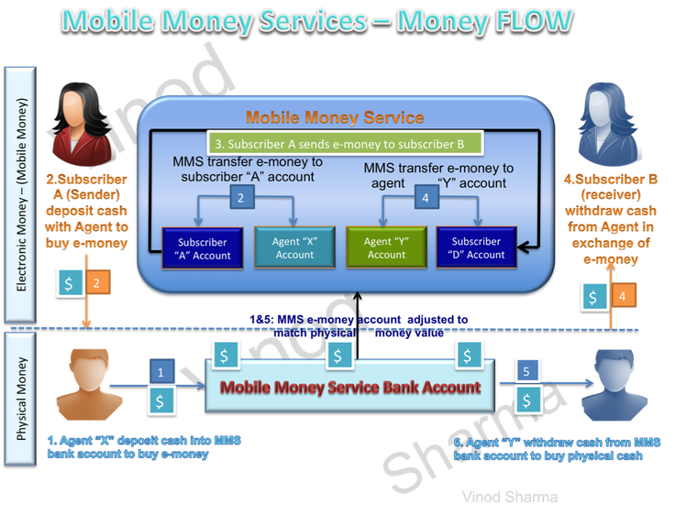**Abstract –**This is the 1st part 1st Chapter of a 5 Chapters story/book on Mobile Financial Services and security on it. Any one looking for some very basic knowledge or introduction on mobile money and critical attributes/ key stake holders along with meaning then this article can help but only on very high level understanding only. Readers who are interested to know some high-level basic information on the subject of Mobile Money or Mobile Payments environments will find this useful. Experts in any form of payments like Mobile Money, mobile payments, Internet payments, paper or card payments may find this article at too basic level but that’s the real idea here. Idea here to share some basic and collective out of all those millions of papers and article available on Internet. Because Mobile phone penetration is soaring and creating huge potential for expanding financial access at a lower cost than through brick-and-mortar branches.

**Introduction –**To date cash is the king but mobile payments/money is making every effort to prove it self as economic freedom and in Africa its no longer needs to prove . Although Mobile Money had been designed as a peer-to-peer payment system but it has gone much beyond the basic idea and as on date it helps Utility bill payments, Airtime topup, micro savings, micro loans etc. and this forms Mobile Payments ecosystems. Africa especially the eastern / southern part is the home of Mobile Money. Mobile Payments are most frequently used and widely acceptable technological payment instruments. Closing the gap between unbanked people with access to mobile phones is one opportunity to scale up access to finance.

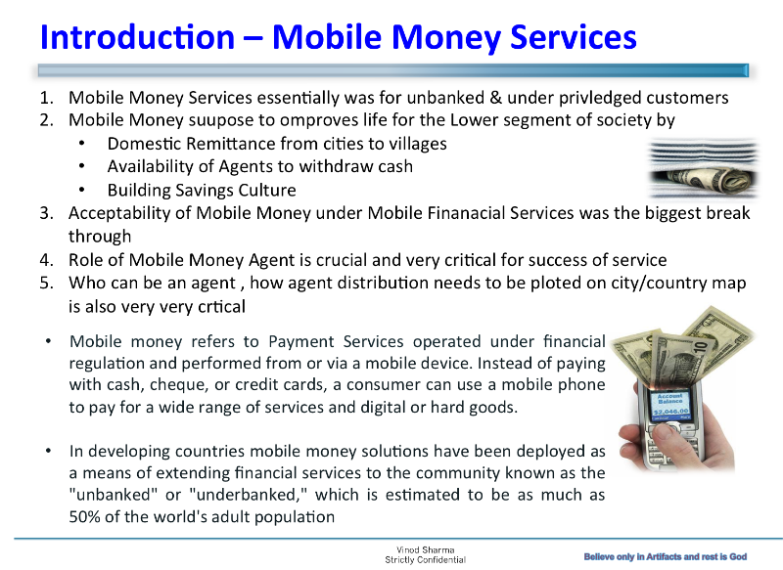

**Main Story –** Africa is the land/Home of Mobile Money and Mobile is most frequently used and widely acceptable technological device then any other. Financial services are a key need for most people due to almost less negligible banking penetration and it makes sense to enable Mobile devices with set of financial tools and features as mobile handset penetration is more then 10 to 15 times higher then banking. Finance sector can take advantages of Mobile devices to penetrate all classes of society so the birth of Mobile Money.  When addressing the opportunities of mobile money in today’s rapidly changing environment, telecommunications operators, financial institutions and technology providers face the challenges of strategy design and modeling, operational efficiency, management of partnerships, risk, compliance and regulatory complexity. Electronic money is the electronic alternative to hard cash, which is in form of bits and bytes of electronic data. Or in short concept/virtual forms our tangible item i.e. physical paper/coin cash.

Electronic monetary values are/can be used for making payment transactions or sending to another person in form of settlement or payments or more specific electronic value products and services. To help our clients address those challenges, Ernst & Young brings together a worldwide team of professionals with deep experience in providing assurance, tax, transaction and advisory services. World is now moving from plastic to mobile phone for payments that also means all the work done in last 20-30 years is now getting scrapped and we are back to basics and shifting our mind set from one side of coin to another side. To achieve faster and quick win here we should adopt the philosophy of Harvey Mackay where he said, “To me, job titles don’t matter. Everyone is in sales. It’s the only way we stay in business”. I personally like this statement, as this is the only way where we can zero in the difference between being data-informed and data-driven.

1. Mobile Money Services essentially was for unbanked & under privileged customers.
2. Mobile Money suppose to improves life for the Lower segment of society by
   1. Domestic Remittance from cities to villages
   2. Availability of Agents to withdraw cash
   3. Building Savings Culture
3. Acceptability of Mobile Money under Mobile Financial Services was the biggest break through
4. Role of Mobile Money Agent is crucial and very critical for success of service
5. Who can be an agent , how agent distribution needs to be plotted on city/country map is also very critical
   1. Mobile money refers to Payment Services operated under financial regulation and performed from or via a mobile device. Instead of paying with cash, cheque, or credit cards, a consumer can use a mobile phone to pay for a wide range of services and digital or hard goods.
   2. In developing countries mobile money solutions have been deployed as a means of extending financial services to the community known as the “unbanked” or “under-banked,” which is estimated to be as much as 50% of the world’s adult population.
6. How Mobile Money Improve life of Lower segment of society
   1. Mobile money is mostly used for domestic remittances. Remittance transactions are usually from cities to villages. They emanate from the need for the working class to take care of the kinsmen in the rural areas. International remittances are also taking good share of this pie
   2. Mobile money thrives on accessibility of services and a wide agent network in both cities and rural areas is required
   3. Savings clubs have been a recent add on to mobile money services and this has assisted club members to save up in an easy and electronic way outside the banking system
7. Acceptability of Mobile Money
   1. Over the years, acceptability of mobile money as payment media has improved with most economies embarking on a cashless society drive to reduce dependence on a paper currency
   2. Most vendors, retailers and transport operators accept mobile payment as an alternative to cash due to its elimination of cash handling expenses and risks
   3. The introduction of NFC driven payments has revolutionised the market for micro payments
8. Role & Importance of Agents
   1. The success of mobile money heavily depends on accessibility
   2. The agent is the primary access channel for mobile money as the conduct agent centered transaction like registrations, cash in and cash out transactions
   3. Agents trade mobile money for a commission
   4. They also act as the first contact for subscribers and it is prudent for a mobile money operator to invest in agent education.
9. Who can/should be an agent
   1. Agent qualification criterion is defined by the operator after considering the requirements of the regulator
   2. Individuals and companies can qualify to be agents and they have to meet the required KYC requirements
   3. The operator’s agent officers are responsible for recruiting and managing relations with the agents.
   4. The density of agents has to be predefined by the operator to maintain profitability of agents as well as accessibility to subscribers.

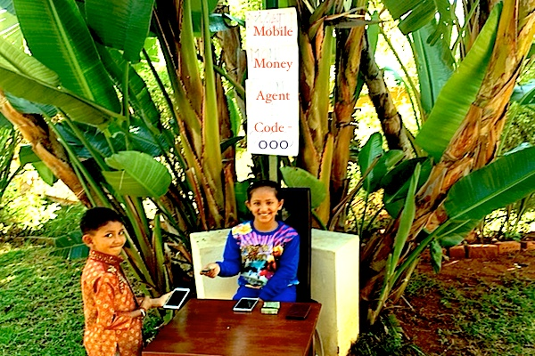

It was taken for granted that Banking (beautiful and useful phenomena) and Bank (long long ago; a big building use to employ lots of people and consume too much space, money, power, and IT machines but use to works very slow and for very limited time of day and weeks) are very tightly coupled and married for ever. MNO and few other companies (Later known as Mobile Financial Service Providers) saw the difference and jumped in between banking and bank and successfully got them divorce or at-least manage to find their relationship with banking. Unfortunately most bankers are still not convinced that these scenarios will play out. These bankers are hoping that their retirements hits before they have to make a decision. The board of directors of a lot of community banks feels that they are the pillars of the community and the relationship will continue to be the answer. Bankers must face facts and learn what is going on outside of their four walls. They may wake up to late.

**Conclusion:**Expanding financial access to the unbanked by Offering convenient and real-time transactions, Dramatically reducing transaction costs, Microfinance Loans and Domestic Remittances, Expanding points of access thus reaching remote areas and Lessening the need to carry cash creating secured & safe way to transact. There is no dull day in Payments business these days. The unglamorous world of clearing and settlement is a recipient of generous attention due to continuous launches of visible overlay propositions, often by non-banks. Established players are constantly anxious about protecting their hard earned franchises, thereby confirming the emergence of the ‘new normal’. To further discussions on how to play the ‘new normal’, we analysed the activities of a range of players and have unearthed ‘8 core traits’ of likely winners. We believe embedding these core elements in the proposition, operating and delivery models will enable players to ‘play to win’ in these turbulent times.